

# Subscriber :

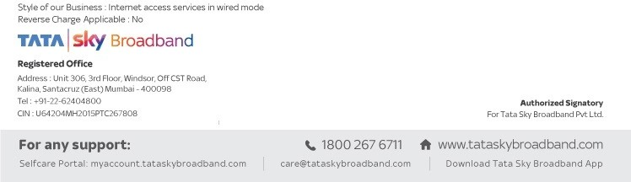

AMIT JOSHI

# Invoice No.:

**Date:**

MH01341823

05/07/2023 18:12

# Customer ID:

C2100973546

**Place of Supply:** Maharashtra

**State with PIN:** Maharashtra-411028

**Address:** 802, Floor-8, Wing-I, Roystonea, Magarpatta City, Hadapsar, Pune Maharashtra - 411028

# Landline Number : PAN No :

**GSTIN :**

**Address:** 3rd Floor, Unit 306,, Windsor, Off C.S.T.

road, Kalina,, Santacruz East,Mumbai

City,

# State Code: 27

**TSBB GSTIN:** 27AAACQ3943P1ZX

Sr. No.

HSN / SAC

Description of Goods / Description of services

Base Amount

Discount Amount

Total Amount

1 998422

Internet Access Services

INR 5,500.00

INR 0.00

INR 6,490.00

**SUMMARY OF CHARGES AMOUNT**

Base Amount Tax Amount CGST @9%

SGST/UTGST @9% IGST @0%

Amount in words

: INR 5,500.00

: INR 990.00

: INR 495.00

: INR 495.00

: INR 0.00

: Rupees Six Thousand Four Hundred Ninety only

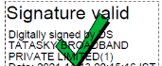

**Jaihind Singh**